RESOLUTION NO.__________

RE: CERTIFICATE OF APPROPRIATENESS UNDER THE
PROVISIONS OF THE ACT OF THE PENNSYLVANIA
LEGISLATURE 1961, JUNE 13, P.L. 282 (53
SECTION 8004) AND BETHLEHEM ORDINANCE NO.
3952 AS AMENDED.

WHEREAS, it is proposed to secure a COA for new signage at 328 South New Street.

NOW, THEREFORE, BE IT RESOLVED by the Council of the City of Bethlehem that a Certificate of Appropriateness is hereby granted for the proposal.

Sponsored by: (s)

(s)

ADOPTED BY COUNCIL THIS DAY OF

(s)
President of Council

ATTEST:

(s)
City Clerk

HISTORIC CONSERVATION COMMISSION

CASE #658 -- It is proposed to mount new lettering to the existing awning above the entrance and to install a new sign to the exterior wall next to the existing entrance at 328 South New Street.

OWNER/APPLICANT: Richard McCormick/Evan Blose (Fast Signs)

The Commission upon motion by Mr. Lader and seconded by Mr. Loush adopted the proposal that City Council issue a Certificate of Appropriateness for the proposed work as presented and described herein:

- The proposal to mount new lettering to the existing awning above the entrance and to install a new sign to the exterior wall next to the existing entrance was presented by Evan Blose.
- Approved new signage includes:
  - 0.25” thick waterjet-cut aluminum letters approx. 11.625” high x 105.75” wide in lower case letters spelling out business name “rakkii ramen” atop existing canopy above entrance doorway at lower level entry; letters stand several inches in front of existing painted plywood awning
  - existing 0.125” thick water-cut steel sign measuring approx. 24” high x 24” wide with medium gray background and warm white logo design that integrates business name “rakkii ramen” … to be installed at right of entrance on existing brick masonry wall; stainless steel masonry pins will be used during installation so signage will project slightly from wall surface
- The motion for the proposed work was unanimously approved.

JBL: jbl
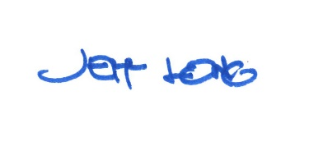

By:

Date of Meeting: July 16, 2018 Title: Historic Officer

